**Practical No.08**

* **Sql Injection Attack**

1. **Search sqlmap.org in browser and download .zip file**

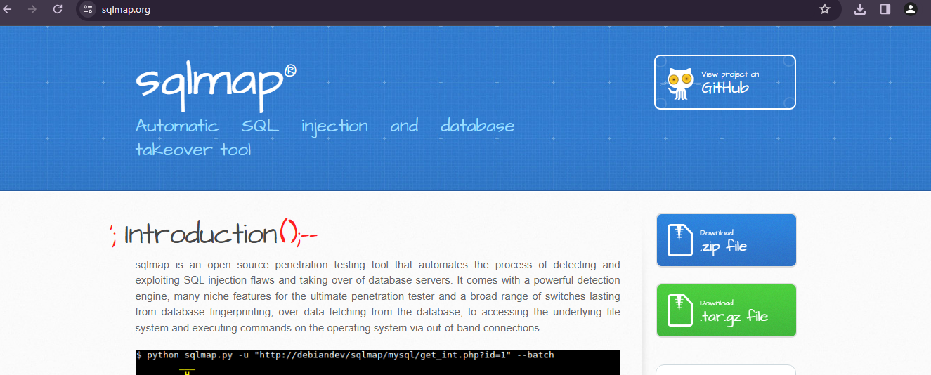

1. **Extract the file and open in cmd**

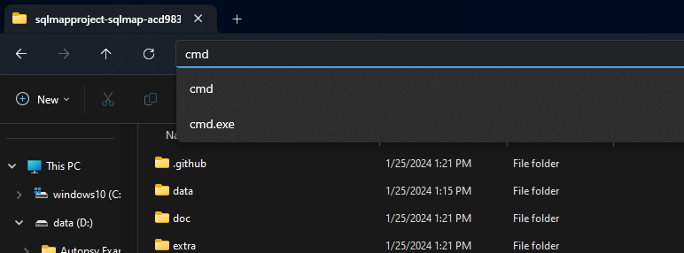

1. **Search testphp.vulnweb.com**

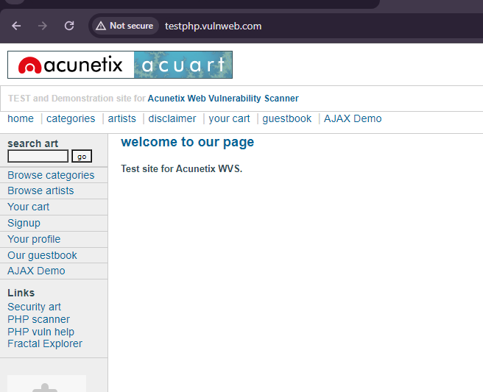

1. **After the open the website page then copy the website and paste it and click on browser history**

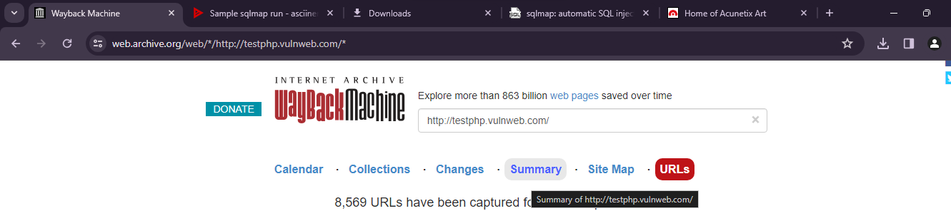

1. **Click the URLs and give input “=1” and copy the the suggested link**

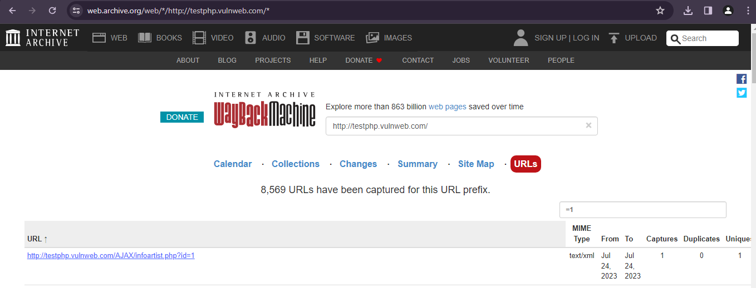

1. **For obtaining dbs**



**Output:**

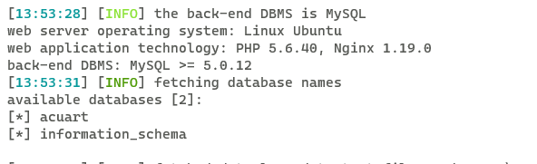

1. **Database name:**



**Output:**

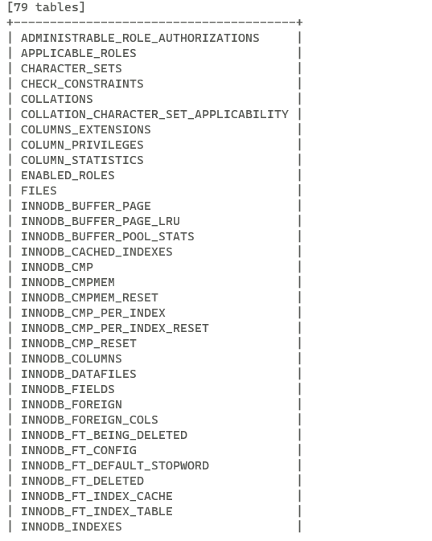

1. **Table name:**



**Output:**

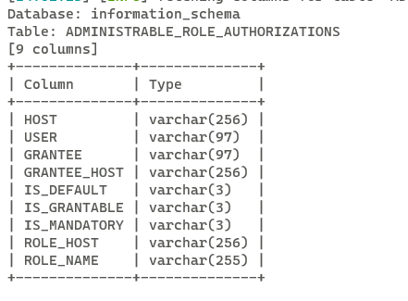

1. **Column name:**

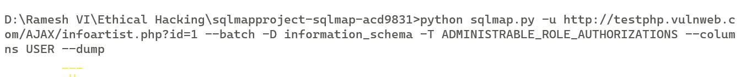

**Output:**

